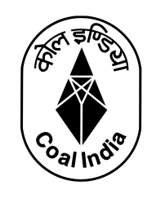
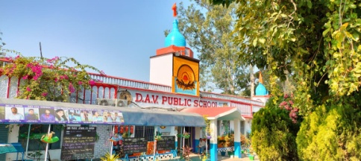
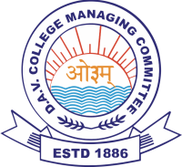

Date: 27.04.26
Jal Pakhwada 2026: Nurturing Young Minds for a Water-Wise Tomorrow
On the meaningful occasion of Jal Pakwada 2026, a vibrant and knowledge-enriching Quiz Competition on Water Conservation and Awareness was organized for the enthusiastic students of Classes III and V.
The quiz was skillfully conducted by Mrs. Shaswati Mukherjee and Mr. Vijay Kumar Pathak, with seamless technical support from Mr. Deepanshu Kumar, ensuring a smooth and engaging experience for all participants.
The young learners participated with great zeal and wholehearted enthusiasm. Their eagerness to respond, presence of mind, and awareness of the current water crisis reflected not only their preparation but also their sensitivity towards one of the most pressing global concerns—water conservation. The questions were thoughtfully curated, aligning closely with real-life challenges and the urgent need to preserve this precious resource.
The competition witnessed a healthy and spirited contest among the houses:
Hansraj House and Tagore House jointly secured the First Position, showcasing remarkable brilliance.
Dayanand House claimed the Second Position with commendable performance.
Vivekananda House earned the Third Position, displaying notable effort and awareness.
Principal Mr. O.P. Goyal lauded the students for their awareness, confidence, and quick thinking. He expressed immense satisfaction, observing that the students of the school, both from the junior and senior wings, are progressing exceptionally well in co-curricular domains alongside academics.
This quiz competition marked yet another impactful activity under Jal Pakwada, specifically dedicated to the Sub-Junior Group, reinforcing the importance of water conservation in young minds and inspiring them to become responsible guardians of our planet.
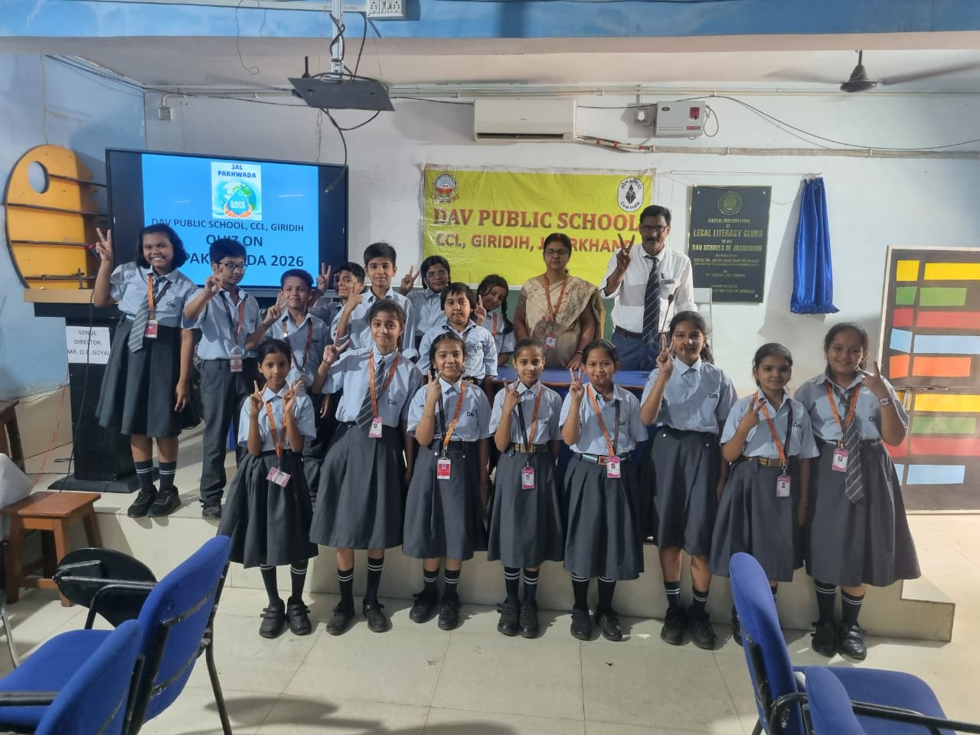
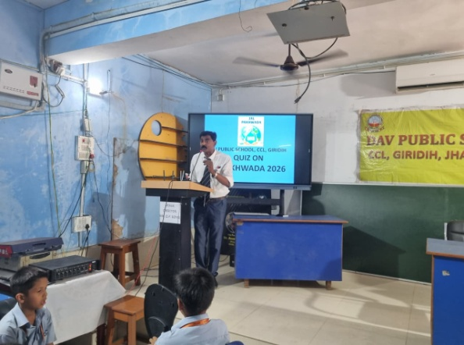
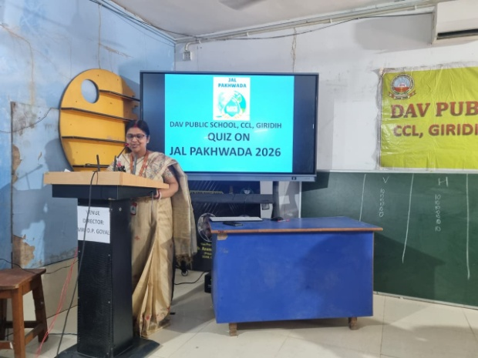
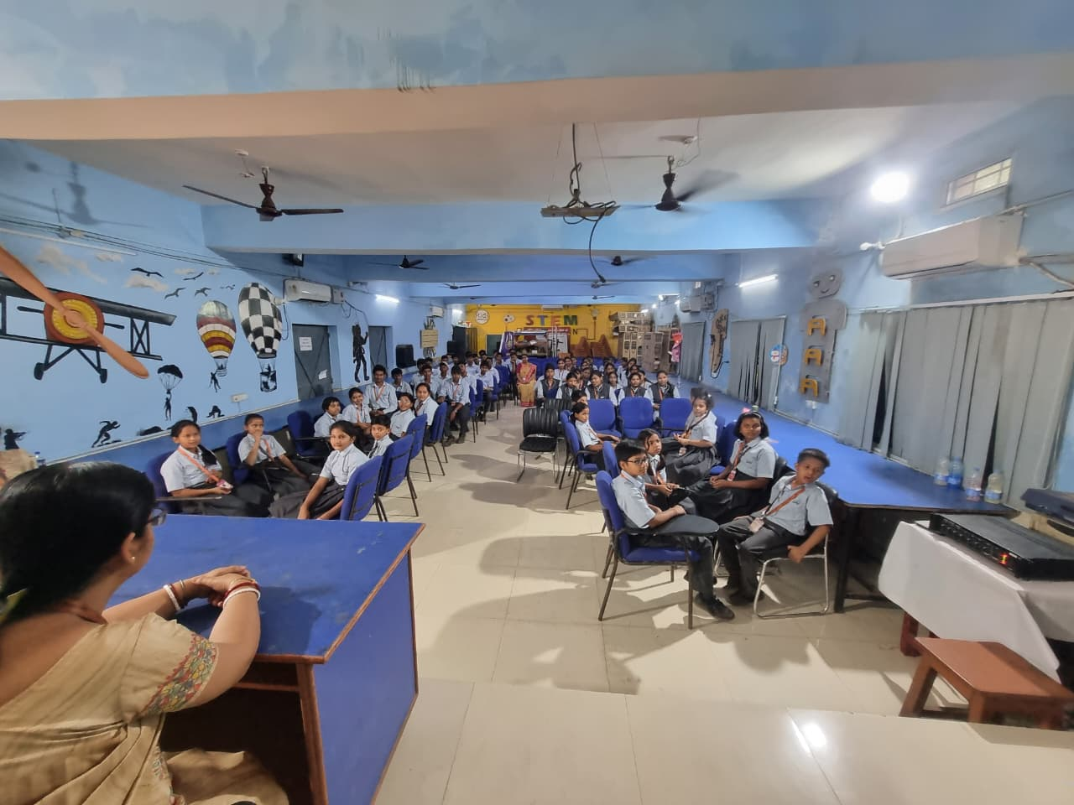
🌍 Indeed, every drop saved today secures a better tomorrow! 💙

